Technical Design Document

Fmod Demo

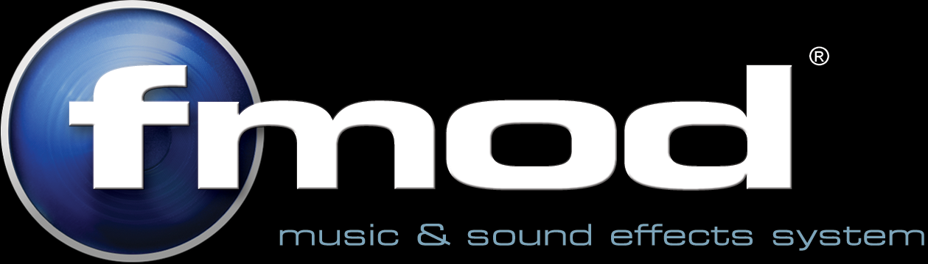

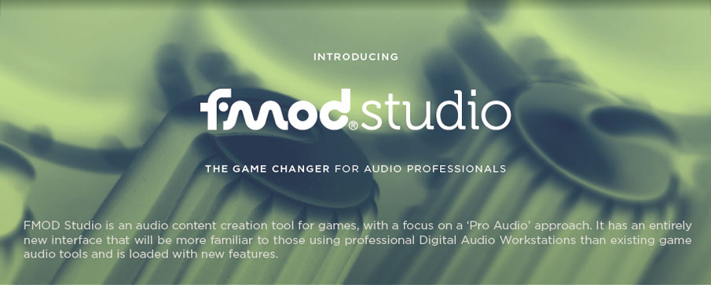

Version: 1.0.0.1
Created 12/07/2016
Last Updated: 03/08/2016
Contents:

1: Overview

2: Technology
  - Summary
    - Engine
    - Platform
    - Tools

3: Level & Menu Elements
  - In-Game Elements
    - Basic
    - Practical
  - Menu Elements

4: UML Descriptions
  - In-Game UML
  - Menu UML

Executive Summary
Overview

The project will be a Unity demo showcasing all the different aspects of Fmod's Unity integration.
Such as: Snapshots, scattering, triggers, etc. It has to be developed based on the idea that anybody should be able to get to a certain Fmod feature in the demo, pull it apart, and understand it as clean as they can. Ideally leading to more people using Fmod over the competitors.

Set in a modern Museum, we have a large corridor (World Hub) with many doors leading to individual 'rooms' (Basic & Practical Scenes). By having each 'room' in a seperate Unity scene, developers should be able to find and access the parts of the demo they wish to learn about without digging through the entire demo.

Technology

Unity is the main focus of this project, even though it already uses Fmod under the hood, there is a large amount of functionality that is inaccessible without the Fmod Unity Integration Plugin and Fmod Studio.

This will be a Unity project and not a build, as it is more of a demo than game that will be pulled apart and utilised on desktop computers that have Unity 5 or later.

Engine

Unity is a very versatile and powerful engine that is being utilised all over the world. Teaching developers ways to use Fmod and Studio in ways they may not have thought were possible is the best way to increase Fmod's user base.

Platform

Windows is the target platform at the moment although, with Unity's flexibility, working with other platforms would not be too difficult if we have the time.

Extras
FMOD Unity Plugin

Fmod's Unity Integration Plugin allows for much more access and control over sounds (events) than is standard in Unity, and also links in directly with Fmod Studio.

FMOD Studio

Fmod Studio is a powerful audio content creation tool, which allows you to create and modify different sounds, events, mixers, buses, etc.

Level & Game Elements
In-Game Elements
Basic

The “Basic” part of the game is where everything is broken down into simple/basic elements, limiting the number of distracting elements in a scene will draw the focus to what we want.
Examples:
- Creating events
- Play/Pause/Stop/Kill events
- Using reverberation zones
- Transceiver events
- 3D Panner events
- Modifying event parameters
- Mixer snapshots

Practical

The “Practical” rooms will have game-play elements as well as one or more audio events/effects to showcase different ways of utilising sound in a game environment. Hopefully inspiring people to be more creative with their sounds and effects.

Menu Elements

The only menu will be in-game, as there is no “Main Menu” like there may be in a game. With this menu you will be able to control what scene you are currently in, while being able to walk in the hub world to the scene you want. Volume controls will also be found in the menu.
UML Descriptions

